Getting started with Dockers

Objective:
Let’s execute a few Docker commands to experiment with Dockers. You will download and install a Docker image from the Docker Hub site https://hub.docker.com/

Docker images are read-only templates that contain instructions for creating a container.
A Docker image is a snapshot of a library and its dependencies required inside a container needed to run.
- First, make sure "Docker Desktop Service" is running
Start a Terminal session (best as Administrator)
You can stop and start this service by typing:
net stop com.docker.service
net start com.docker.service
Best to just run Docker desktop which starts the docker service and enables the docker CLI.
- Lets try to install a Docker on your PC.
docker run -d -p 81:80 nginx
This command will pull an nginx image and then creates a container to run it.
If the image exists, it will not download (pull) the image. It may take a minute to run this particular container!
Port 81 will be used for nginx but you can change this to any free port on your PC.

NGINX is an open-source web server software used for reverse proxy, load balancing, and caching.
- Test this docker by browsing to: http://localhost:81/
Please note http:// not https://

- Type the following command in the Terminal window to view all the images installed on your PC:
docker images
Take a note of the nginx’s image ID.
- Type the following command to view all the Dockers that are currently running:
docker ps
Take a note of the nginx’s container ID.
- Type docker stop <nginx ID>
Tip: Just type a few starting letters of the nginx’s container ID.
- Refresh the browser at http://localhost:81/
You will encounter “This site can’t be reached”

- Start the container by typing docker start <nginx ID>

- Refresh the browser at http://localhost:81/
and notice the web page is fine.
- Remove the nginx’s container by name – Type docker ps
This command shows all the currently running dockers

(please note the random name created for this container! We can change it)
Type: docker stop <docker name> (from the right column)
docker rm <docker name> (from the right column)

Tip: You can see that it is easier to remove a docker using a few letters of its ID!

- Type: docker images to see all the images on your PC.
- Remove the nginx’s image by typing: docker rmi <imageid>
(just type just part of the image ID)

- Type: docker pull nginx
To get the docker image only, but will not run it
- Type docker ps -a
and notice there is no nginx container
The -a option displays all Docker containers, including those that have stopped running.
- Practice removing this image before moving to the next section

Search Docker Hub from the command line
- To search your docker hub repo, you must first login.
Login to docker hub by typing: docker login

- Search for possible images of Nginx
- Type the following command and view the list:
docker search nginx

- Pull an image down with the command
docker pull nginx

- Let’s tag this image. Tag lets us edit an image and save it to our own personal registry
docker tag nginx your-Docker Hub-user name /my-nginx

- view the images which are saved locally
docker images

- Push this image to your Docker Hub.
docker push your-Docker Hub-user name /my-nginx
You can now search for your copy of nginx either in the Docker hub site or in command line: docker search your-Docker Hub-user name /my-nginx

- You can delete our local image(s)
docker ps
docker rmi nginx
docker rmi your-Docker Hub-user name/my-nginx

- Let’s install Nginx with a name of nginxDemo
docker run -d -p 81:80 --name nginxDemo nginx
-d : detached, logs aren't outputted to the terminal
-p : port publishing, <host port (your PC)>:<container port (nginx docker)>
--name : what you want to name the container, if no name is given a random name is given
The last word (nginx) is what image to build the container from

- Check all the images running: docker ps

- Try Test the Nginx docker in a browser:
http://localhost:81

Make changes to your Nginx container
- Interact with the nginx container
You can execute a command within a running Docker container and run commands inside a container to interact with the processes running in it. The following command runs a bash command which is the Unix’s shell command (terminal)
docker exec -it nginxDemo bash
-it flag means interactive

- Update package manager and install the Nano editor.
Type the following command in the Nginx Terminal:
apt update
apt install nano -y
apt update: update the package index files on the system, which contain information about available packages and their versions. It downloads the most recent package information from the sources listed in the "/etc/apt/sources.list.d" file that contains your sources
The -y option stands for yes! This prevents the system from prompting you with questions during installation and automatically accepts the default settings.

- Modify the Nginx’s start up screen:
cd /usr/share/nginx/html
and then edit it by typing: nano index.html
Make some changes (style/text), save and then exit the nano editor
(view the bottom of the screen for how to save)
Escape the terminal interaction by typing: exit

- Test the changes that you’ve made
http://localhost:81/

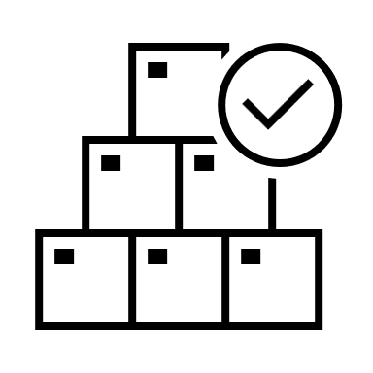Congratulations, you have successfully created a Docker, modified the code inside the docker and learned about the basic docker CLI command.

